|  |  |
| --- | --- |
| **R E P O R T** | |
|  |



|  |  |
| --- | --- |
| **학 과** | **전기전자정보시스템공학전공** |
| **교수님 (Professor)** | **KANG, HEE-JUN 교수님** |
| **학 번 (Student ID)** | **20175308** |
| **이 름 (Name)** | **La Phuong Ha** |
| **제출일 (Times)** | **20190927** |



La Phuong Ha – ID: 20175308 – Assignment 3: Robot Manipulators

ECCL | #7-429 | Email: [laphuongha@gmail.com](mailto:laphuongha@gmail.com)

Program Forward Kinematics for Puma 560 Robots using Matlab

1. Find ${}_{T}^{0}T$ s

Matlab code:

%Parameter of Manipulator

th1 = pi/4;

th2 = pi/4;

th3 = pi/4;

th4 = pi/4;

th5 = pi/4;

th6 = pi/4;

a2 = 1; a3 = 0.3; d3 = 0.5; d4 = 1;

T6_T = [1 0 0 0;0 1 0 0;0 0 1 0.2;0 0 0 1];

%D-H parameters

syms a1 a d th,

T = [cos(th) -sin(th) 0 a;

sin(th)*cos(a1) cos(th)*cos(a1) -sin(a1) -sin(a1)*d;

sin(th)*sin(a1) cos(th)*sin(a1) cos(a1) cos(a1)*d;

0 0 0 1];

T01 = vpa(subs(T,{a1,a,d,th},{[0,0,0,th1]}),2);

T12 = vpa(subs(T,{a1,a,d,th},{[-pi/2,0,0,th2]}),2);

T23 = vpa(subs(T,{a1,a,d,th},{[0,a2,d3,th3]}),2);

T34 = vpa(subs(T,{a1,a,d,th},{[-pi/2,a3,d4,th4]}),2);

T45 = vpa(subs(T,{a1,a,d,th},{[pi/2,0,0,th5]}),2);

T56 = vpa(subs(T,{a1,a,d,th},{[-pi/2,0,0,th6]}),2);

T06 = vpa(T01*T12*T23*T34*T45*T56,2)

T0_T = T06*T6_T

The output of Matlab: T06

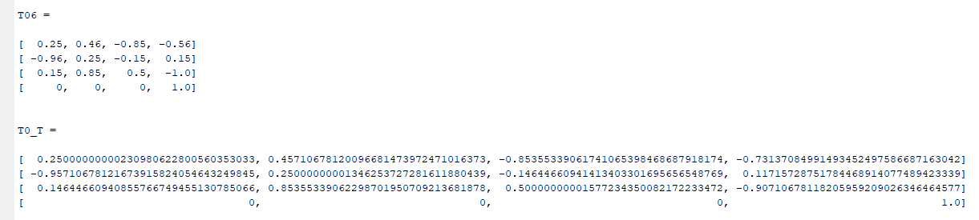

1. 8 sets of solution:

%calulate T0_T, T06 with the code in a.

%problem b: 8 set parameter

px = T06(1,4);

py=T06(2,4);

pz=T06(3,4);

r=T06(1:3,1:3);

th = zeros(6,8);

th(1,1:4) = atan2(px,py) - atan2(d3, sqrt(px^2 + py^2 -d3^2));

th(1,5:8) = atan2(py,px) - atan2(d3, sqrt(px^2 + py^2 -d3^2));

K = (px^2 + py^2 + pz^2 - a2^2 - a3^2 - d3^2 - d4^2)/(2*a2);

th(3,[1,2,5,6]) = atan2(a3,d4) - atan2(K, sqrt(a3^2 + d4^2 + K^2));

th(3,[3,4,7,8]) = atan2(a3,d4) - atan2(K, -sqrt(a3^2 + d4^2 + K^2));

th23 = atan2((-a3-a2*cos(th(3,:)))*pz + (cos(th(1,:))*px + sin(th(1,:))*py).*(d4-a2*sin(th(3,:))),(a2*sin(th(3,:))-d4)*pz+(a3+a2*cos(th(3,:))).*(cos(th(1,:))*px + sin(th(1,:))*py));

th(2,:) = th23 - th(3,:);

th(4,:) = atan2(-r(1,3)*sin(th(1,:))+r(2,3)*cos(th(1,:)),-r(1,3)*cos(th(1,:)).*cos(th23) + r(3,3)*sin(th23));

s5 = -r(1,3)*(cos(th(1,:)).*cos(th23).*cos(th(4,:)) + sin(th(1,:)).*sin(th(4,:))) - r(2,3)*(sin(th(1,:)).*cos(th23).*cos(th(4,:)) - cos(th(1,:)).*sin(th(4,:))) + r(3,3)*sin(th23).*cos(th(4,:));

c5 = -r(1,3)*cos(th(1,:)).*sin(th23) - r(2,3)*sin(th(1,:)).*sin(th23) - r(3,3)*cos(th23);

th(5,:) = atan2(s5,c5);

s6 = -r(1,1)*(cos(th(1,:)).*cos(th23).*sin(th(4,:)) - sin(th(1,:)).*cos(th(4,:))) - r(2,1)*(sin(th(1,:)).*cos(th23).*sin(th(4,:)) + cos(th(1,:)).*cos(th(4,:))) + r(3,1)*sin(th23).*sin(th(4,:));

c6 = r(1,1)*((cos(th(1,:)).*cos(th23).*cos(th(4,:)) + sin(th(1,:)).*sin(th(4,:))).*cos(th(5,:)) - cos(th(1,:)).*sin(th23).*sin(th(5,:))) + r(2,1)*((sin(th(1,:)).*cos(th23).*cos(th(4,:)) - cos(th(1,:)).*sin(th(4,:))).*cos(th(5,:)) - sin(th(1,:)).*sin(th23).*sin(th(5,:))) - r(3,1)*(sin(th23).*cos(th(4,:)).*cos(th(5,:)) + cos(th23).*sin(th(5,:)));

th(6,:) = atan2(s6,c6);

th(4,[2 4 6 8]) = th(4,[2 4 6 8]) + pi;

th(5,[2 4 6 8]) = -th(5,[2 4 6 8]);

th(6,[2 4 6 8]) = th(6,[2 4 6 8]) + pi;

th

The output of the matlab code:

